# Configuring the Sonar Jenkins Plugin

## Adding Sonar Server

You can define as many Sonar servers as you wish. Then for each Jenkins job, you will be able to choose which server to use for the Sonar analysis.

To add sonar server, just follow the three steps below:

1. Log into Jenkins as an administrator and go to Manage Jenkins > Configure System:

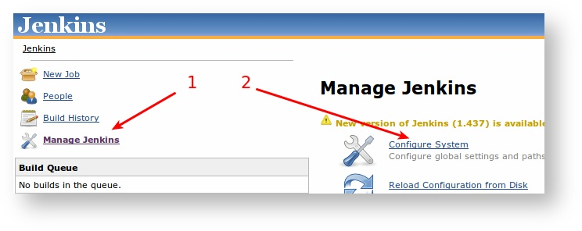

1. Scroll down to the Sonar configuration section and click on Add Sonar:

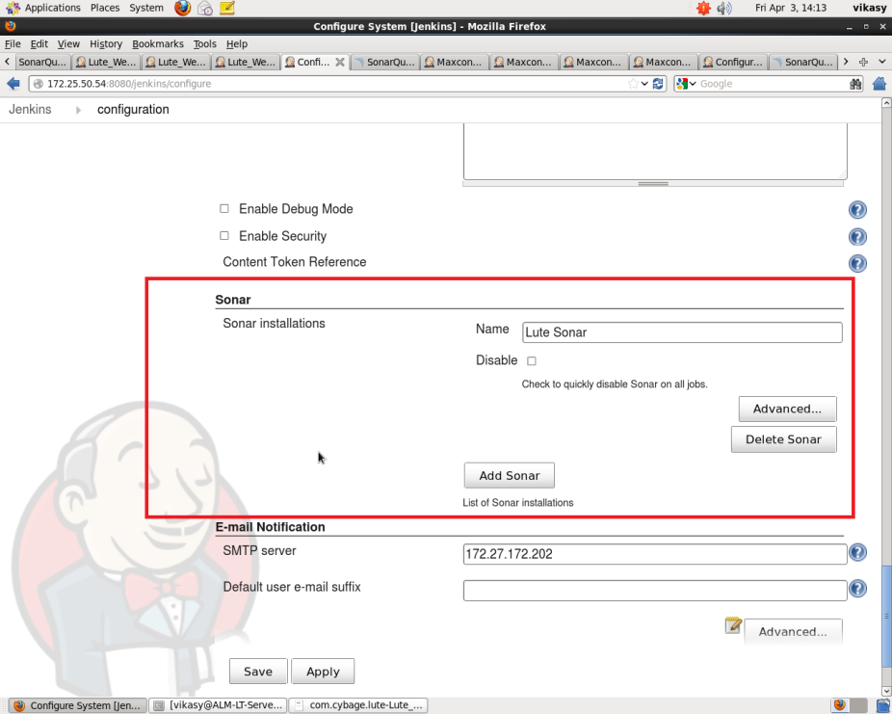

1. Configure your Sonar installation by clicking on the "Advanced..." button :

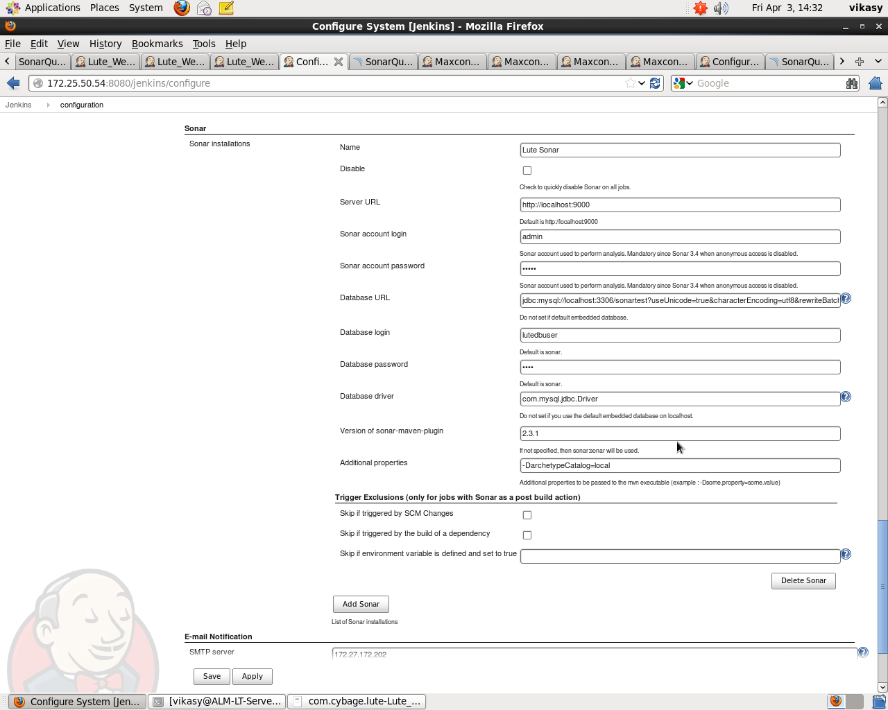

For the JOB LEVEL CONFIGURATION, go to that particular job and click on CONFIGURE tab.

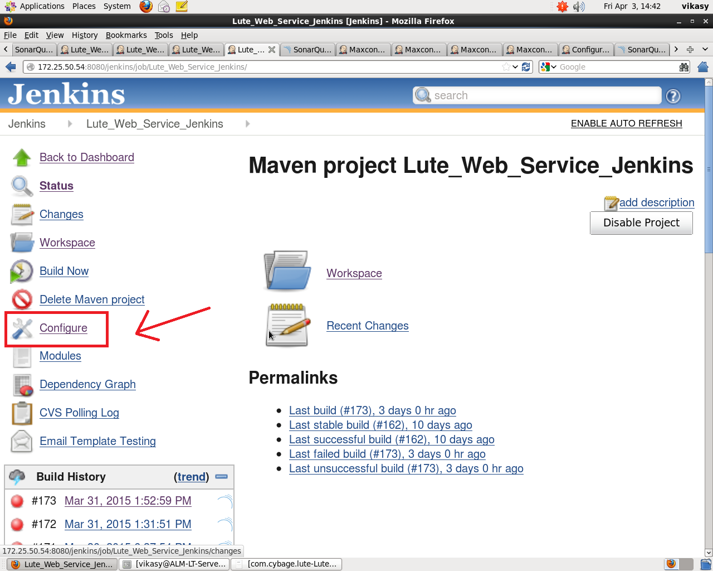

1. Scroll down and go to ‘Pre-build Steps’ and click on ‘Add Pre-build step’:

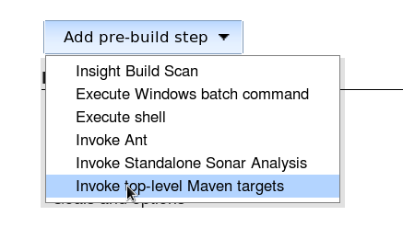

1. Click on Invoke top-level Maven target:

* For Cobertura reports in Jenkins, specify the maven version and goals.

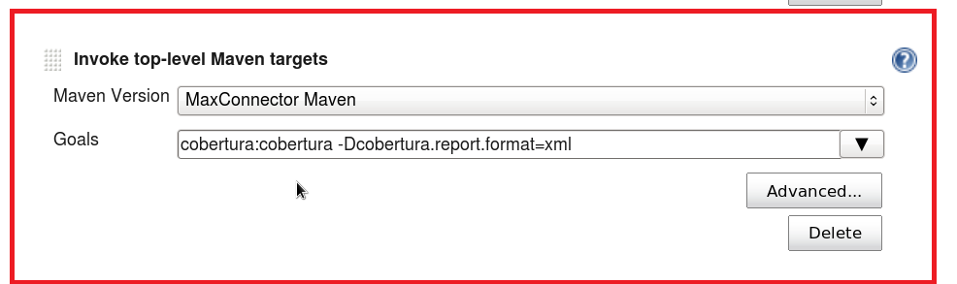

1. Click on ‘Add Pre-build step’ and ‘Invoke Standalone Sonar Analysis’.

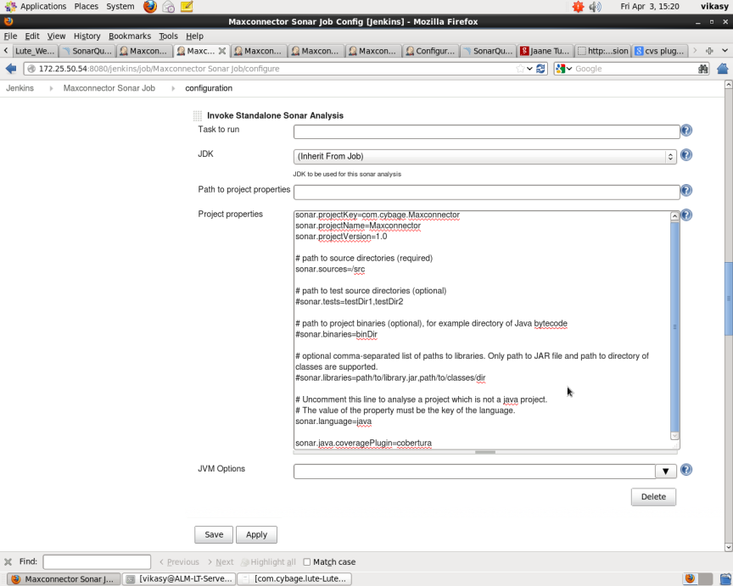

Specify the Project Properties file:

sonar.projectKey – unique key in sonar to represent your project.

sonar.projectName – name of the project in sonar.

sonar.projectVersion – version of a project.

sonar.sources – your source folder.

## Displaying Cobertura Reports in SonarQube Dashboard:

## Sonar Web Browser View:

The **Web** view displays the main project dashboard (for project) or the component viewer (for class or file).

This web page can also be used to access information and services (Clouds, Hotspots, etc.) that are not available in SonarQube Eclipse.

As shown below Dashboard gives overall report for all issues divided into Blocker, Critical, Major, Minor, Info and also other parameters such as Unit tests Coverage, Rules compliance, Unit test Success, Lines of code, Duplications, Complexity etc.

1. SonarQube dashboard

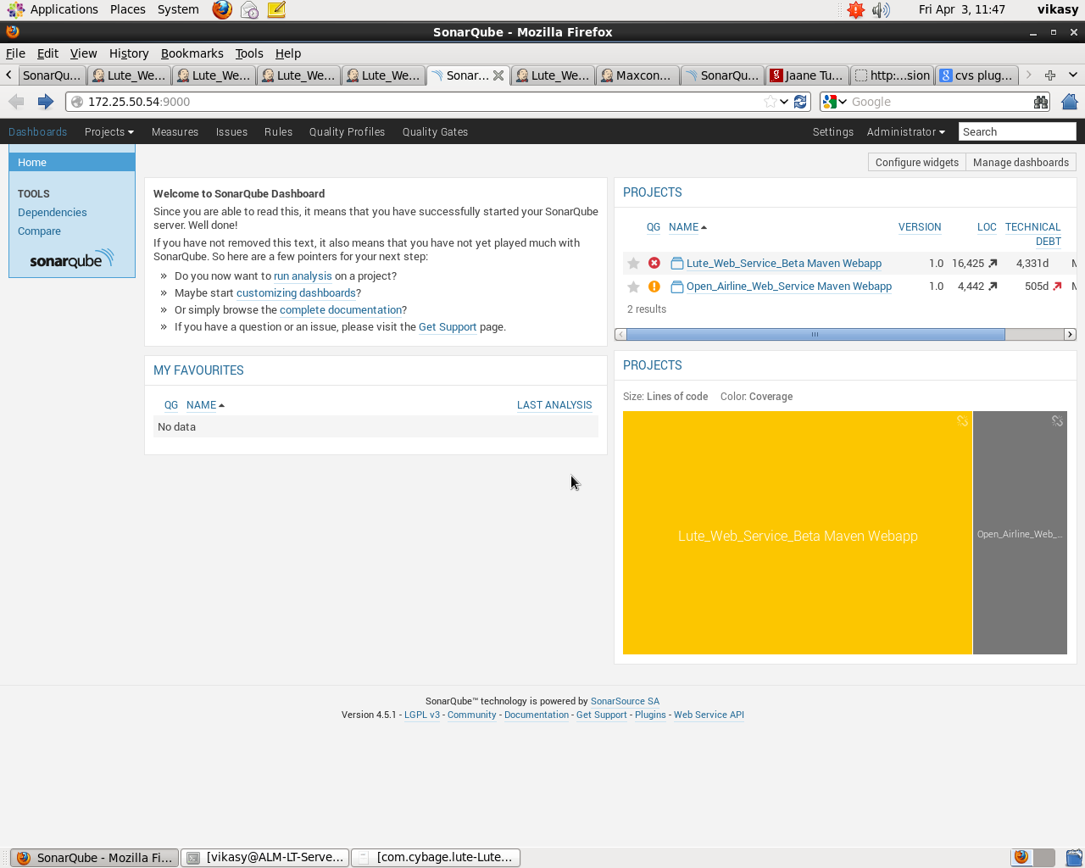

1. Analysis of a Project

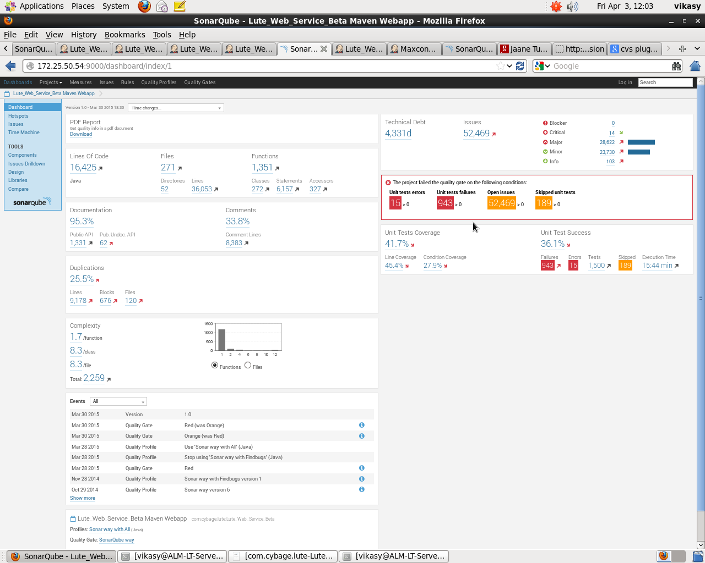

1. How to check Unit Test coverage

* Go to Settings 🡪 General Settings 🡪 Choose CATEGORY as Java
* Set the path of JUnit Reports in JUnit as: **target/surefire-reports/**
* Save JUnit Settings.
* Path for Cobertura Reports will be the default path.
* Save Cobertura settings.

For JUnit Reports:

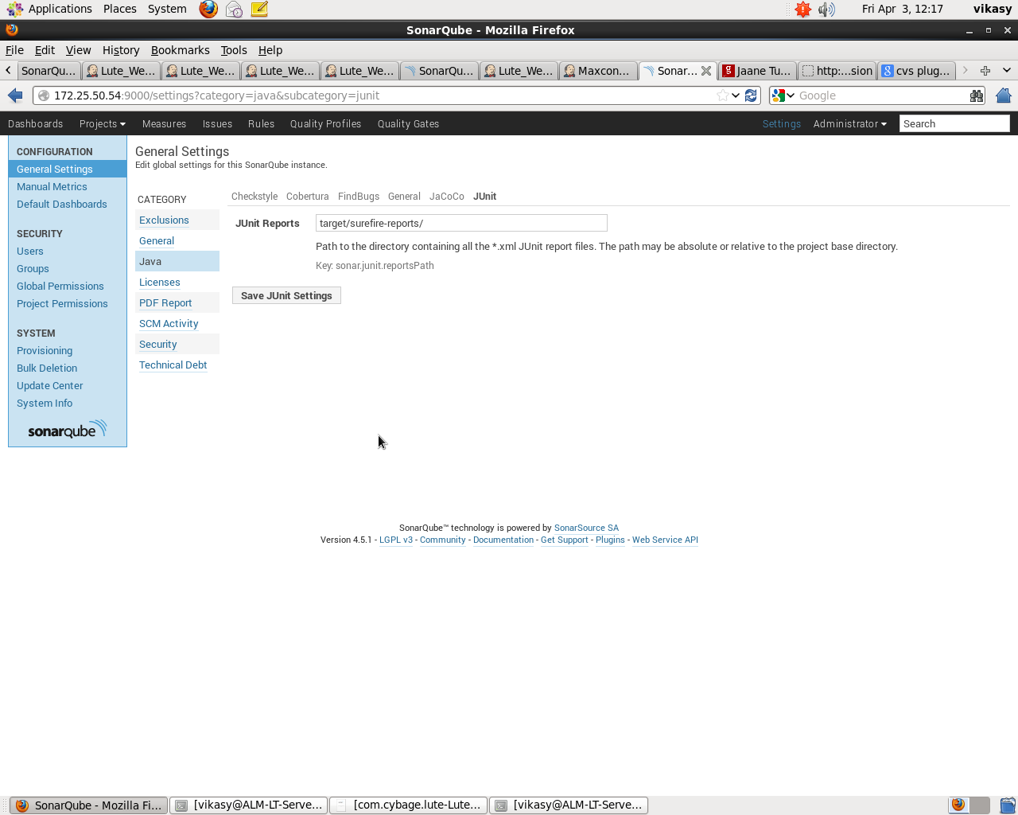

For Cobertura Reports:

